**Practical No: 1**

**Aim:** Creation of Dimensions and Fact tables.

Solution:

Open Application -> Microsoft SQL Server 2008 R2 -> SQL Server Management Studio

1. Select Connect Tab -> Database Engine -> Select Server Name(local)
2. Right Click the Database -> New Database
3. Types “SalesInformation” as the database name, click on OK to close the dialog box and to create the databse.

Create a Database Diagrams

Expand the “SalesInformation” database folder.

1. Click on Database Diagrams to expand it

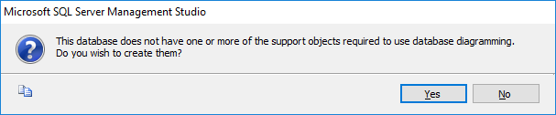

On click of it, above Dialog box appears, click on Yes to close it.

1. Right Click on Database Diagrams -> New Database Diagrams
2. Create fact and Dimension Tables. (Right click on surface, choose New Table to add tables on Database Diagrams.)

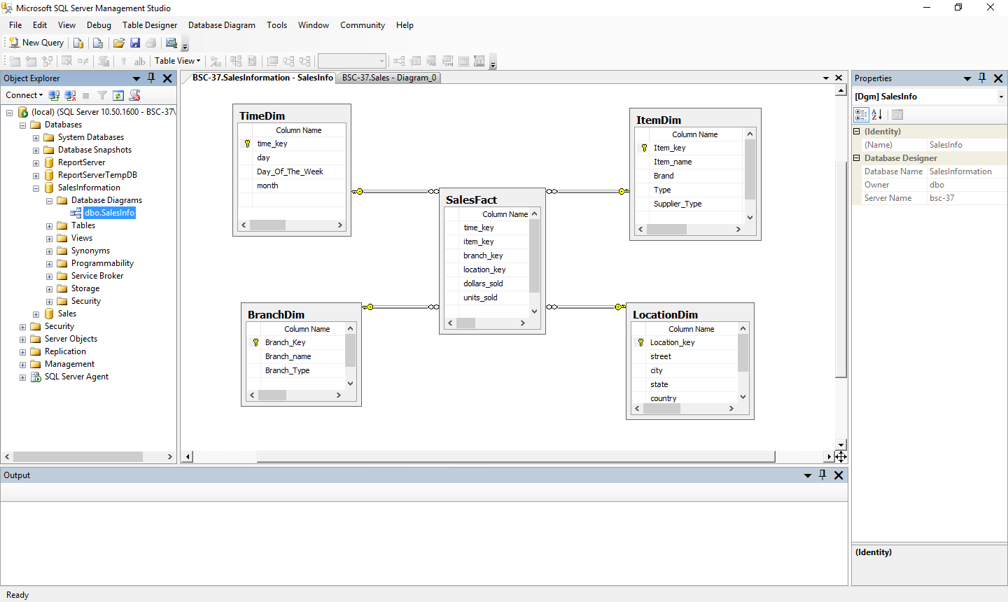

1. Establish relationship between fact and dimension tables.
2. Save Database Diagrams with name as “SalesInfo”. (After saving Database Diagrams fact and dimension tables are automatically placed in Table tab.)

**Practical No: 2**

**Aim :** Create Data Source using SSAS(SQL Server Analysis Services.)

Solution :

Open Application -> Microsoft SQL Server 2008 R2 -> SQL Server Business Intelligence Development Studio

1. Select File -> New Project -> Choose Analysis Service Project -> Name it as “SalesInfo_BIPrj” and click on OK.
2. Right Click on Data Sources -> New Data Source

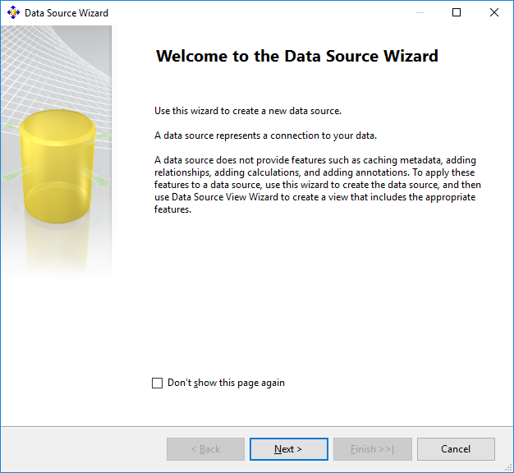

Click on Next.

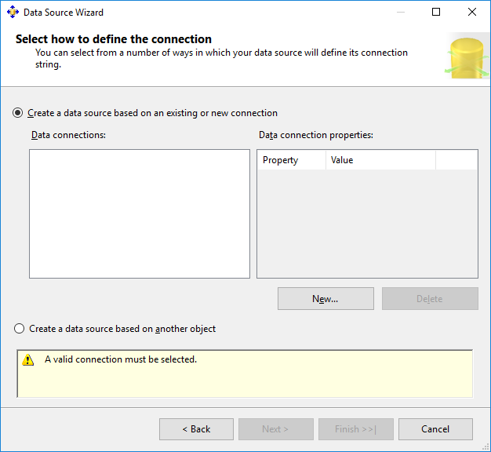

Click on New.

1. Choose Provider as “Microsoft OLEDB Provider for SQL Server” , Server Name as “.”, Select database name as “SalesInformation”.(Created in SQL Server Management studio).

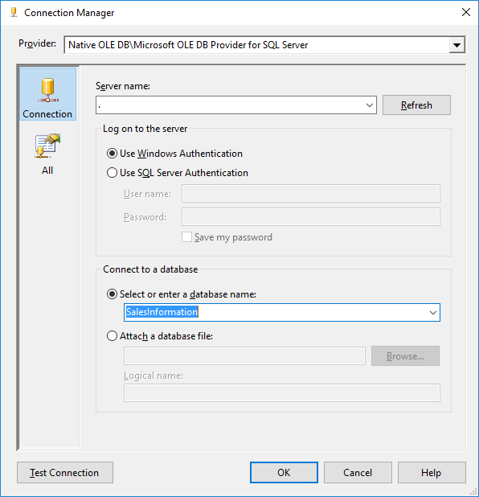

1. Click on Test Connection.

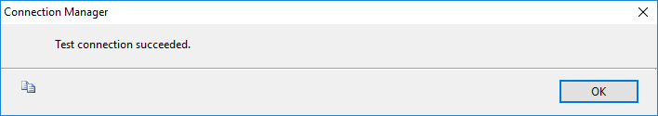

Click on OK.

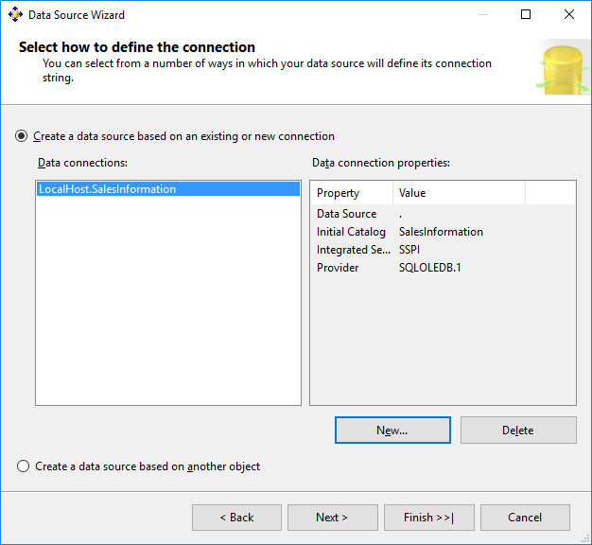

Click on Next

1. Choose “Inherit” option.

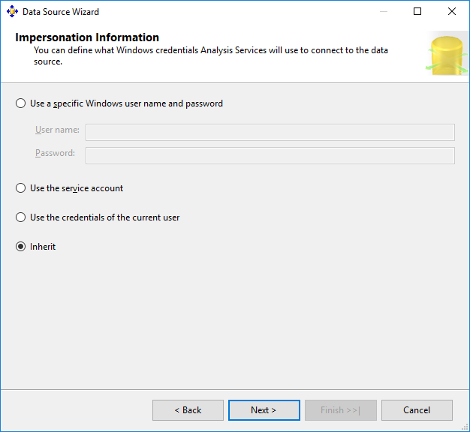

Click on Next.

1. Click on Finish.

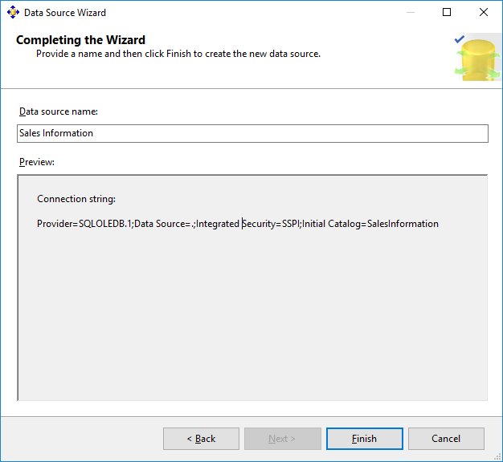

Name Data Source as “Sales Information”.

**Practical No: 3**

**Aim:** Create Data Source View using SSAS(SQL Server Analysis Services.)

Solution:

1. Right click on Data Source View -> New Data Source View

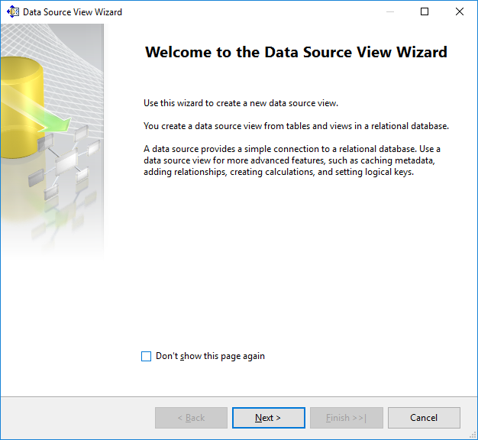

Click on Next.

1. Click on Next.

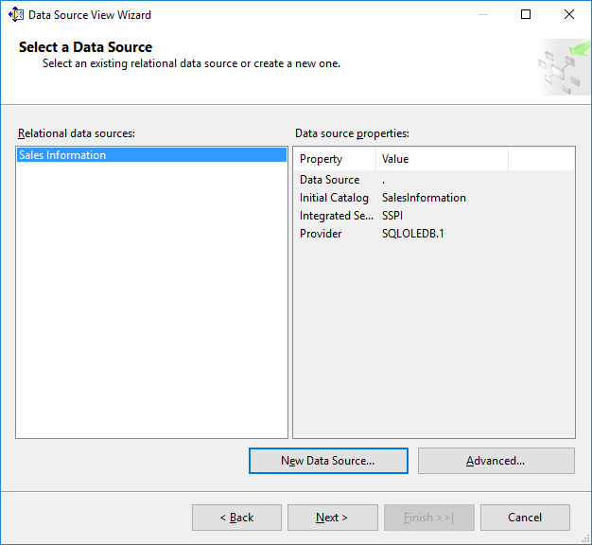

1. Select Tables and Views.

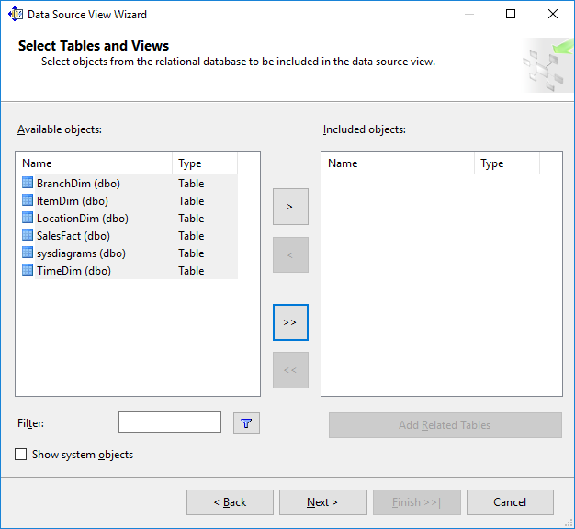

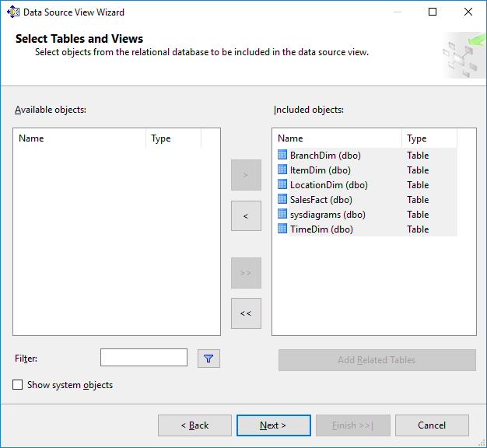

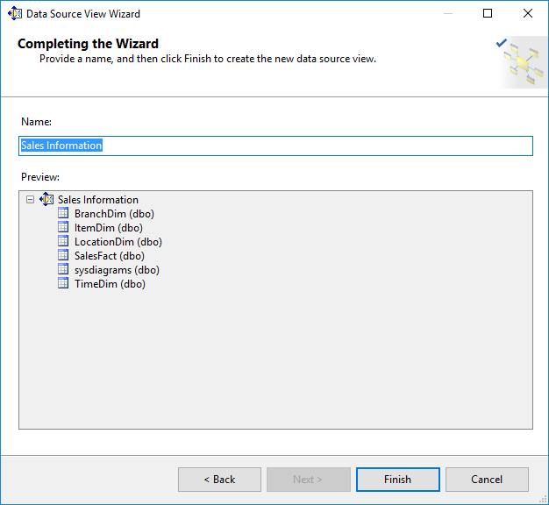

Click on Finish.

1. Finally, we will get the Data Source View like:

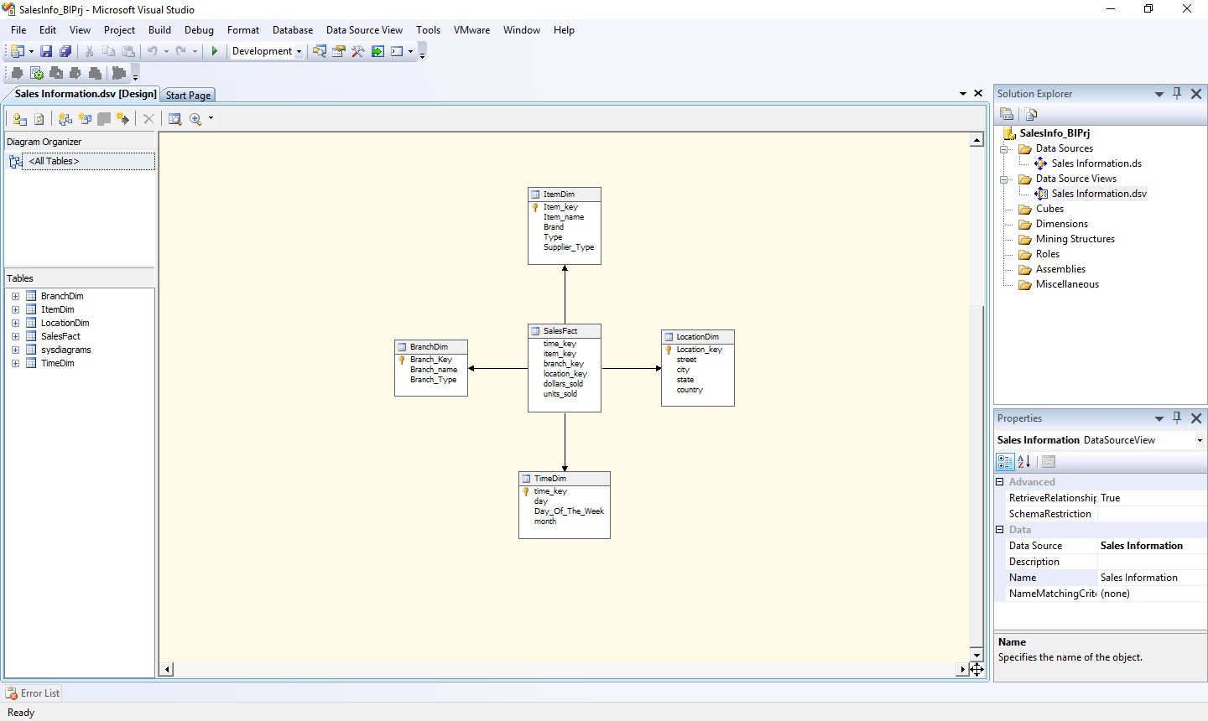

**Practical No: 4**

**Aim:** Create cube using SSAS(SQL Server Analysis Services.) and process the cube.

Solution:

1. Right click on Cubes -> New Cube.

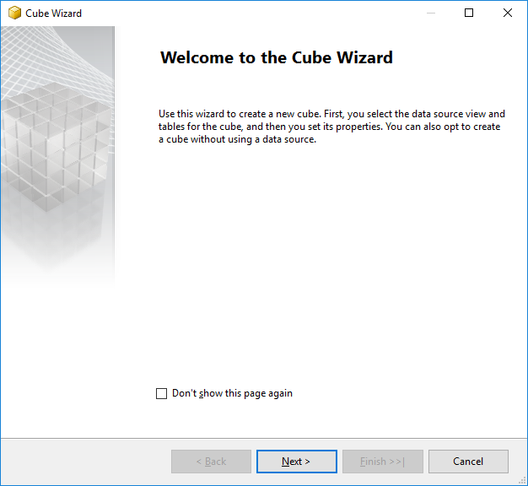

Click on Next.

1. Select First option “Use existing tables”. Click on Next.

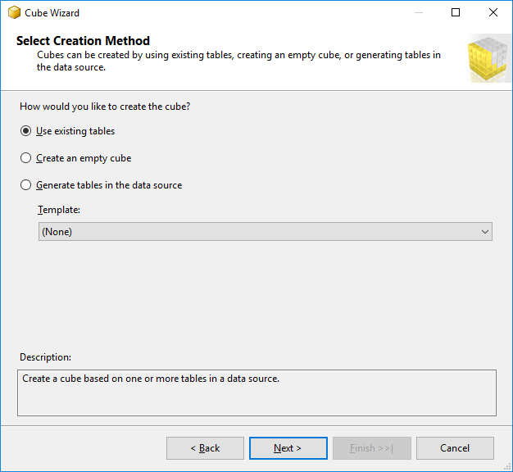

1. Select Data Source View as “Sales Information” and Select all the tables.

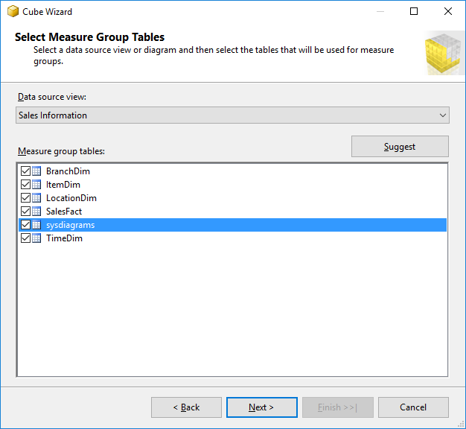

Click on Next.

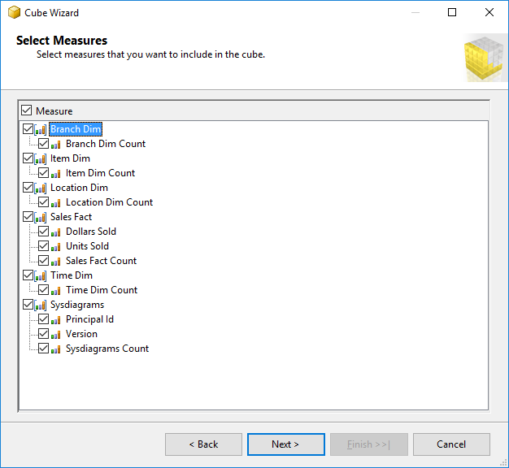

Click on Next.

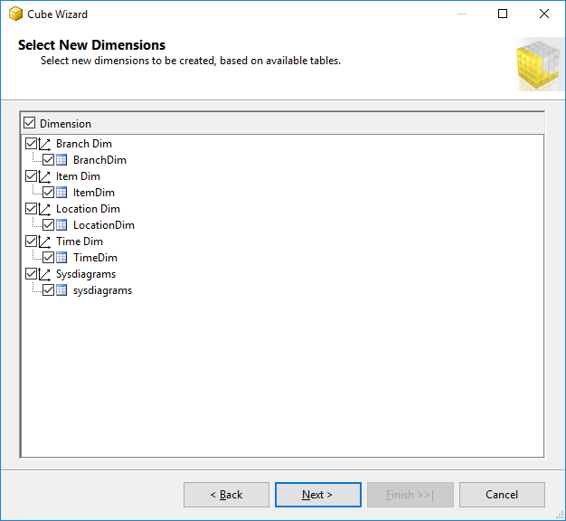

Click on Next.

1. Name Cube as “SalesCube”.

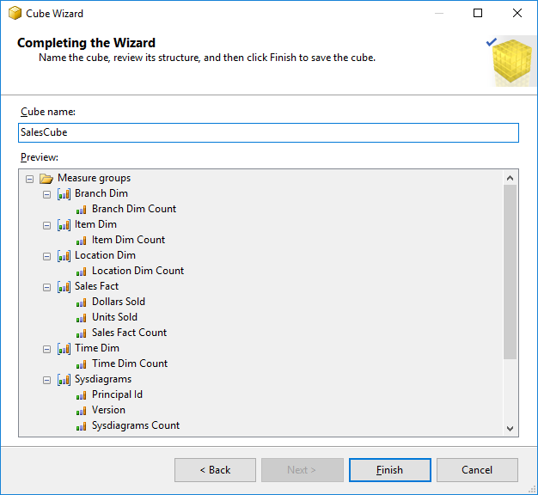

Click on Finish.

1. Finally, we will get the Cube View as well Dimensions View like :

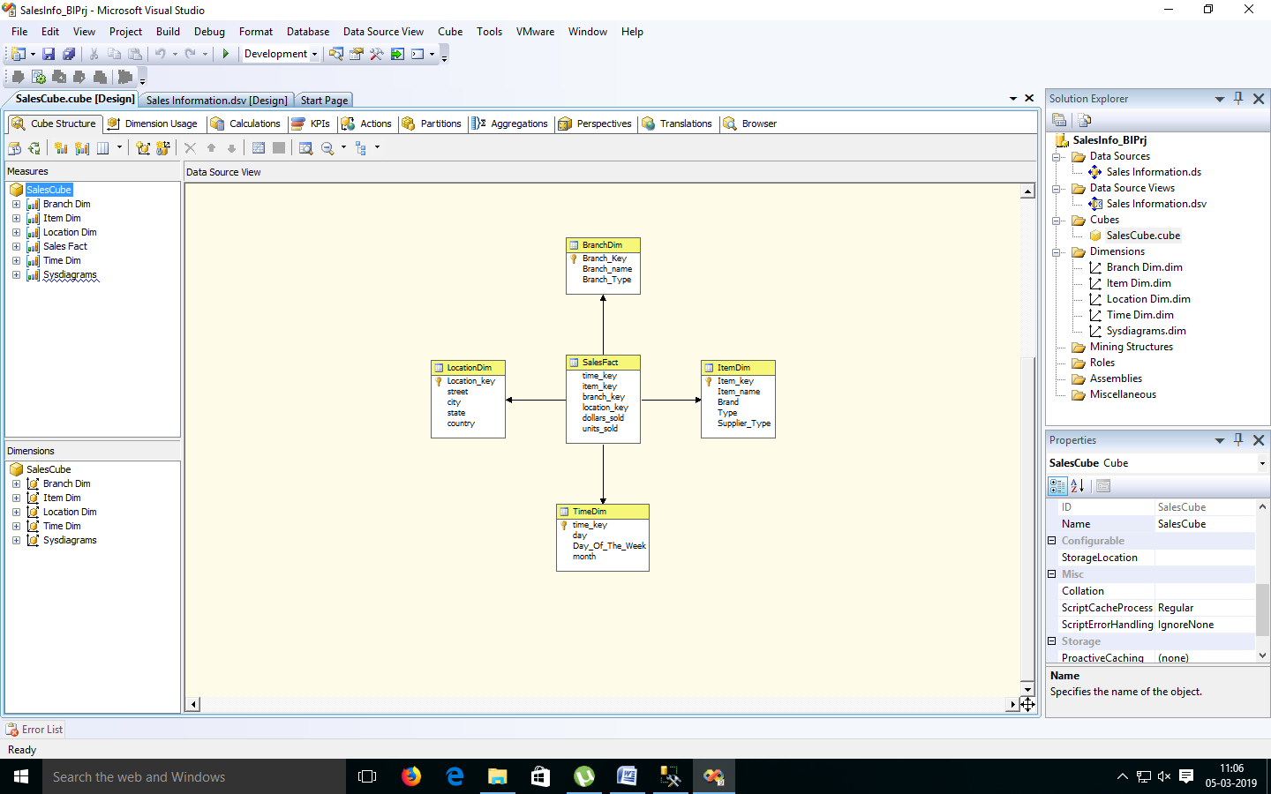

1. Finally, Process cube by Right click on SalesCube -> Process **.**

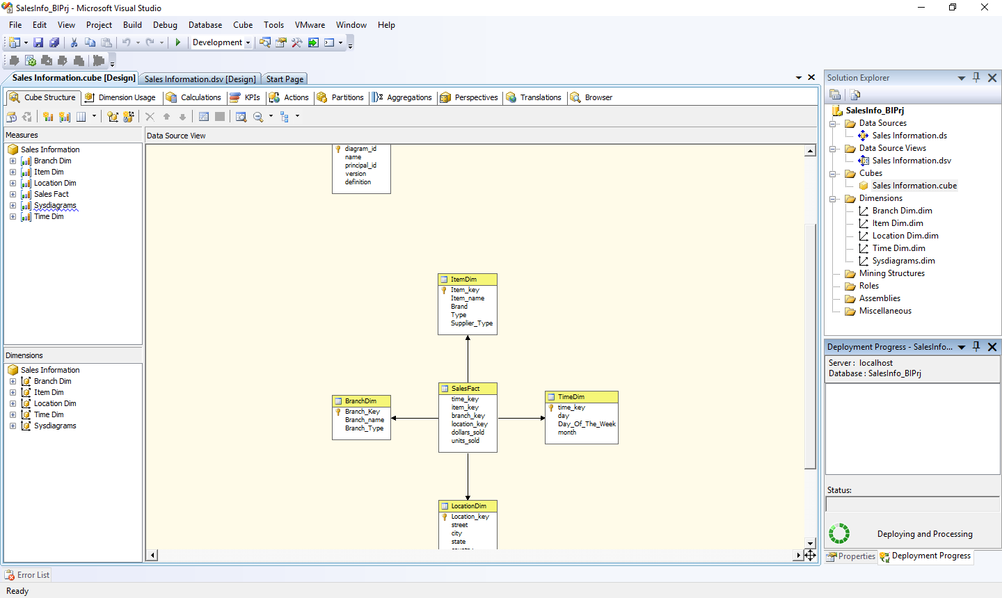

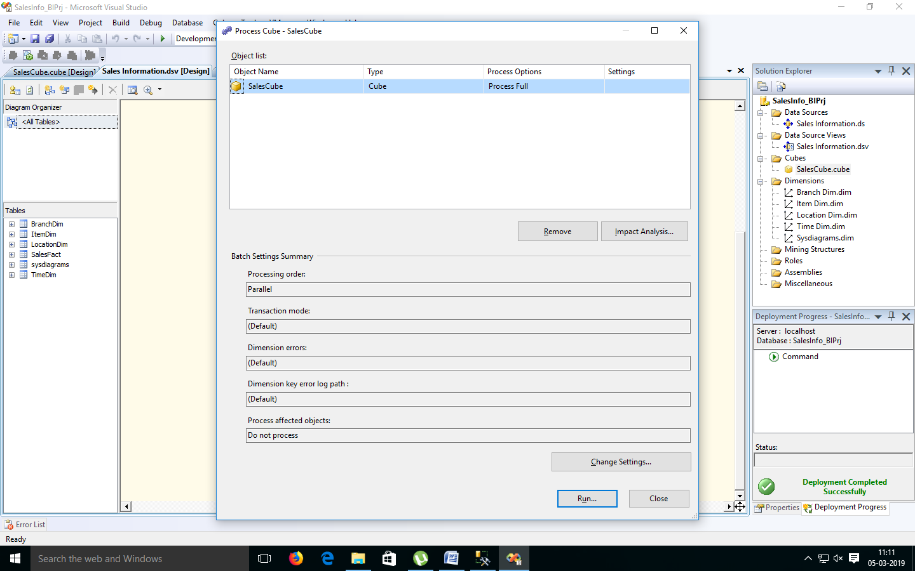

1. Click on Run.

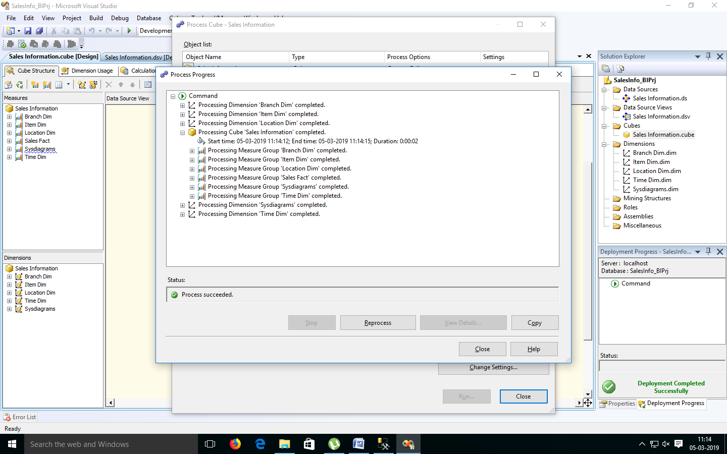

**Practical No 5**

**Aim:** Creating an Excel Pivot Table and Pivot Chart by using the OLAP cube data.

Solution:

1. Open MS-Excel. Click on Data Menu.
2. Go to From Other Sources.
   1. From SQL Server -> Type Server name as “.”

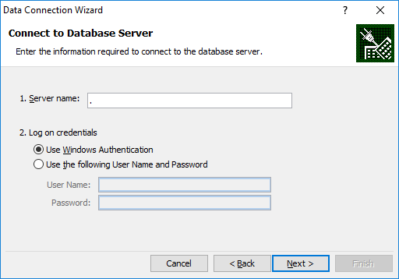

Click on Next.

Choose SQL Database -> “SalesInformation”

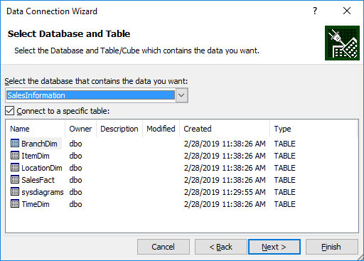

* 1. From Analysis Services -> Type Server name as “.”



Click on Next.

Choose Analysis Database as “SalesInfo_BIPrj”. Click on Next.

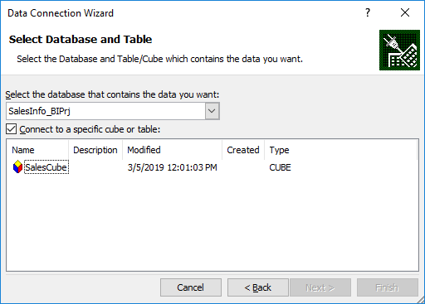

Click on OK

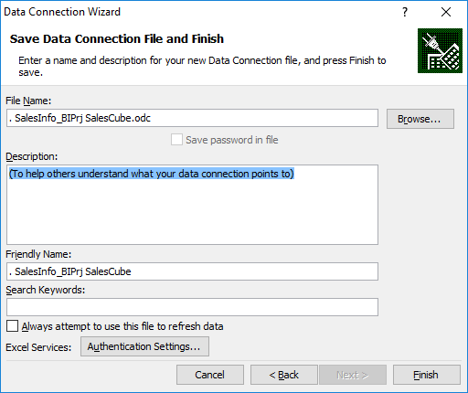

Click on Finish.

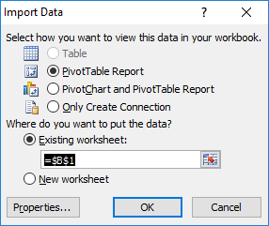

Click on OK.

1. Select Item Key, Location Key and Measures as Dollars Sold, Units Sold and Sum Dollars Sold

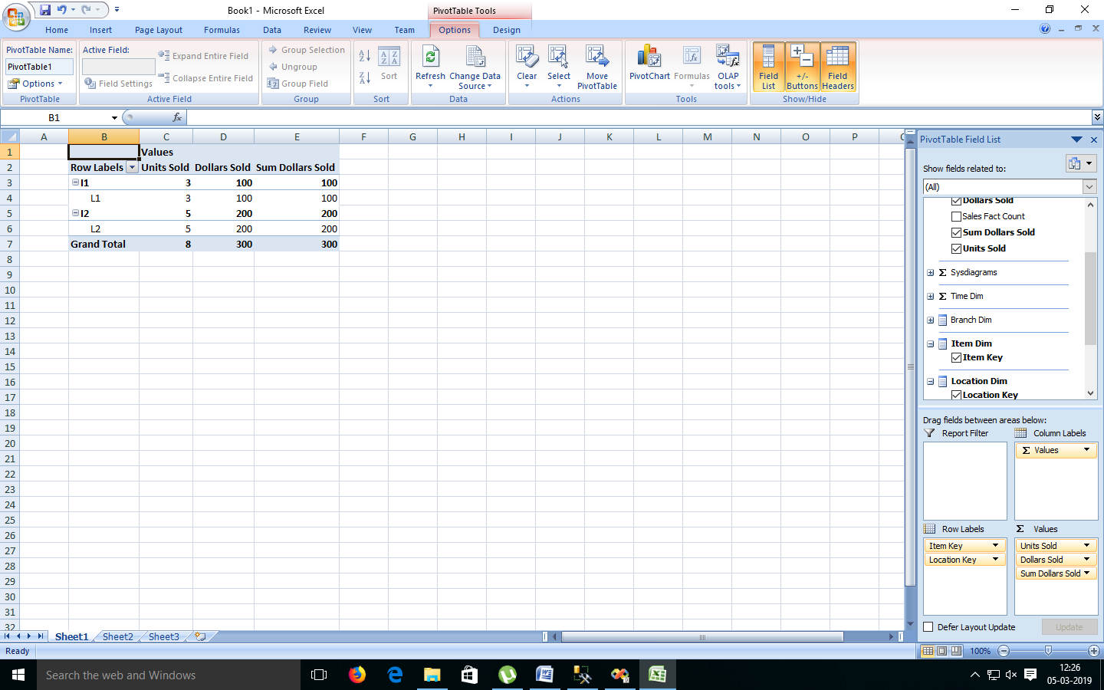

1. Select Result Area. Go to Insert Menu. Select Pie Chart option.

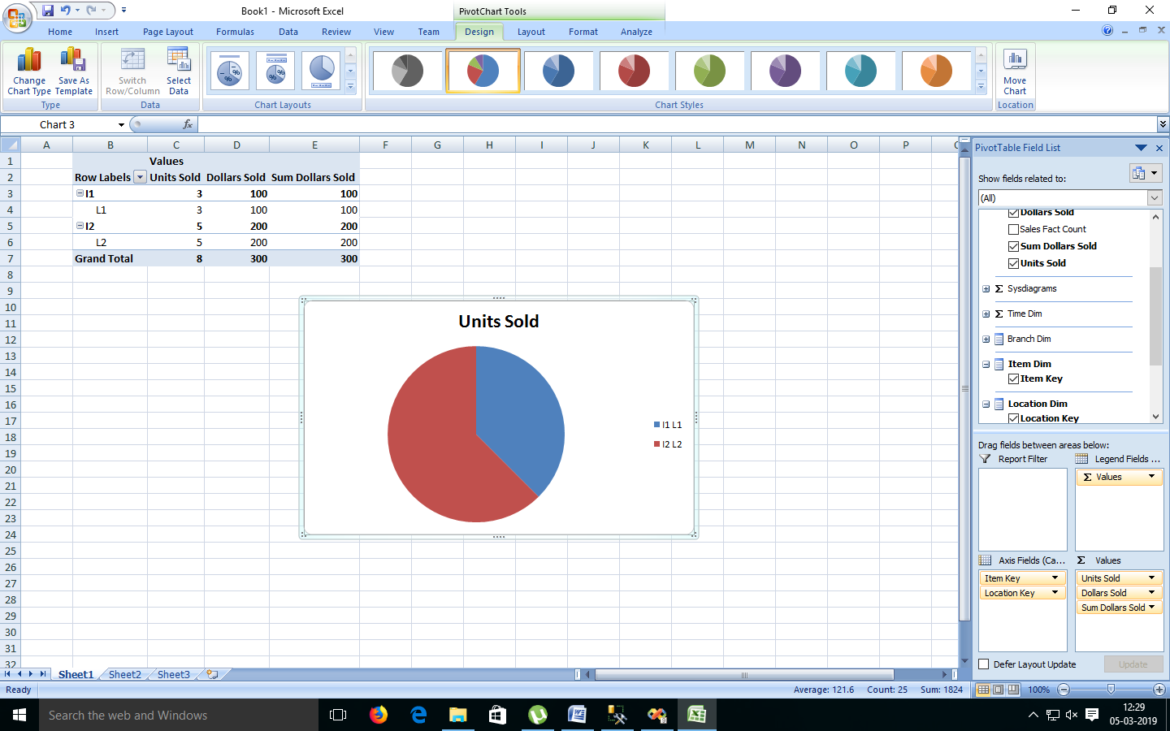

1. Select Result Area. Go to Insert Menu. Select Column option.

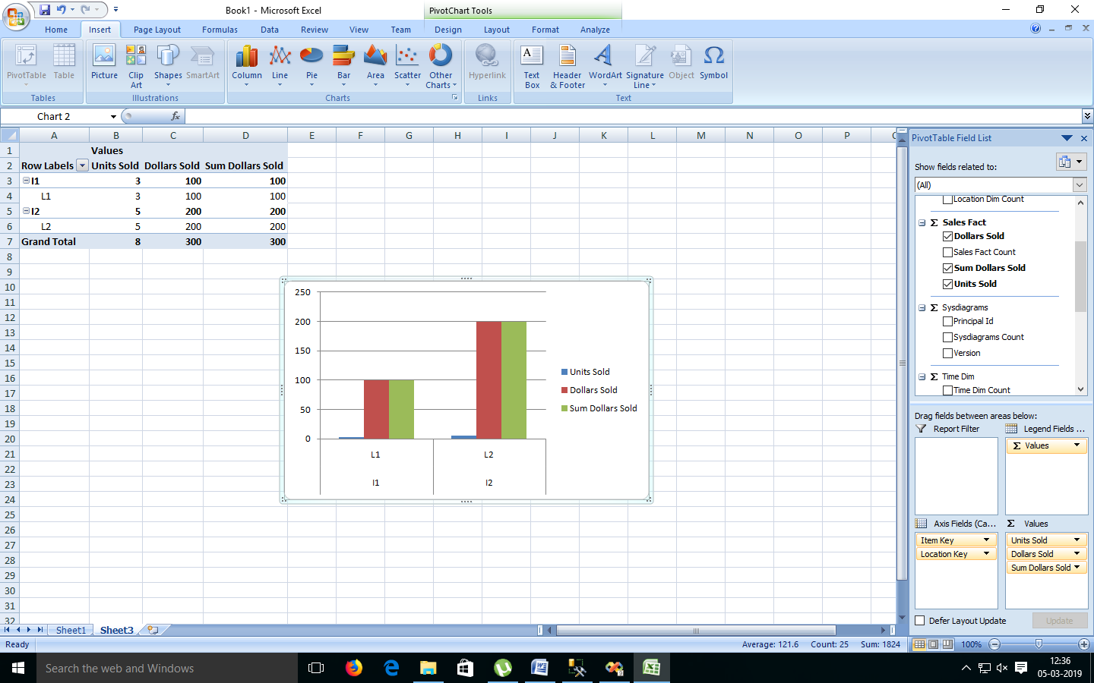

**Practical No: 6**

**Aim:** Data Pre-Processing ,

Open Weka > click on Explorer

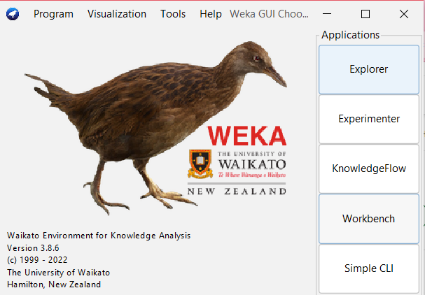

* In Explorer > go to Preprocess

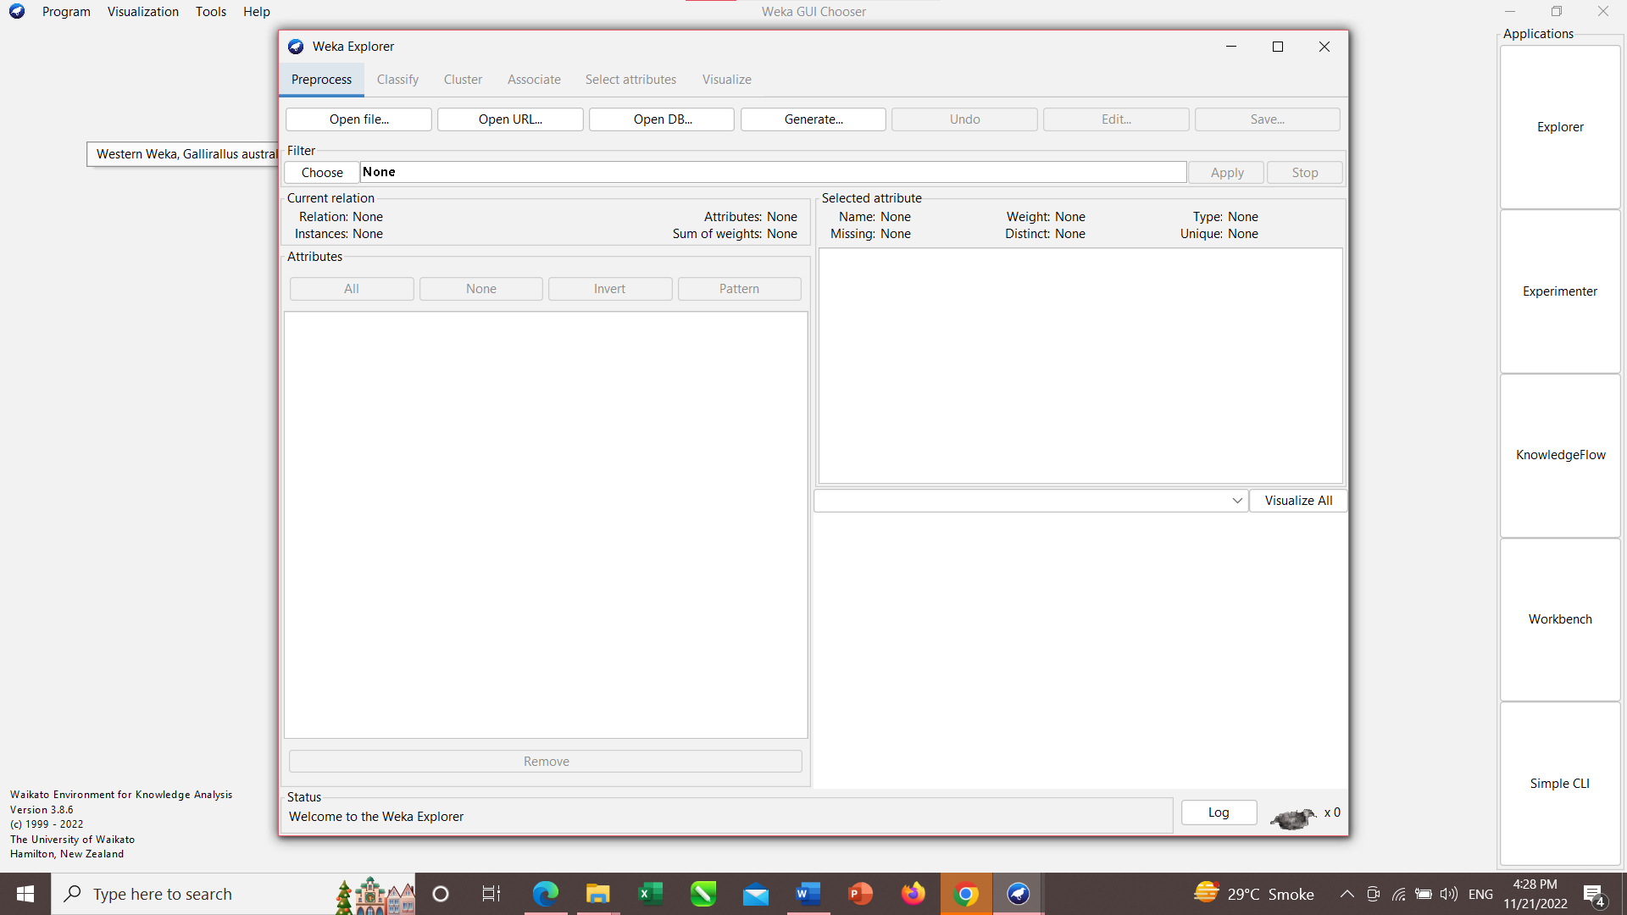

**Practical No: 7**

1. **Classification Problems:-**

In Preprocess > Open file> Local disk> Program files> Weka > Data>choose weather file> open

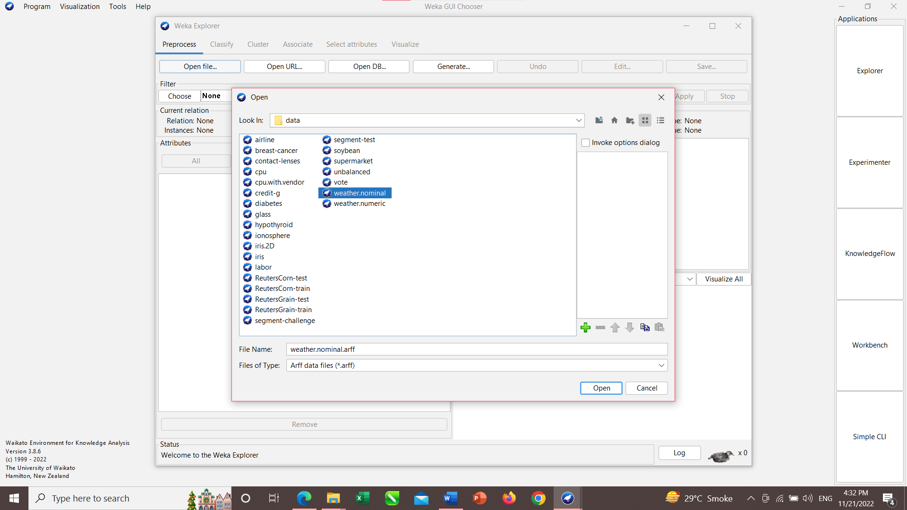

* After clicking on open u will see this window.

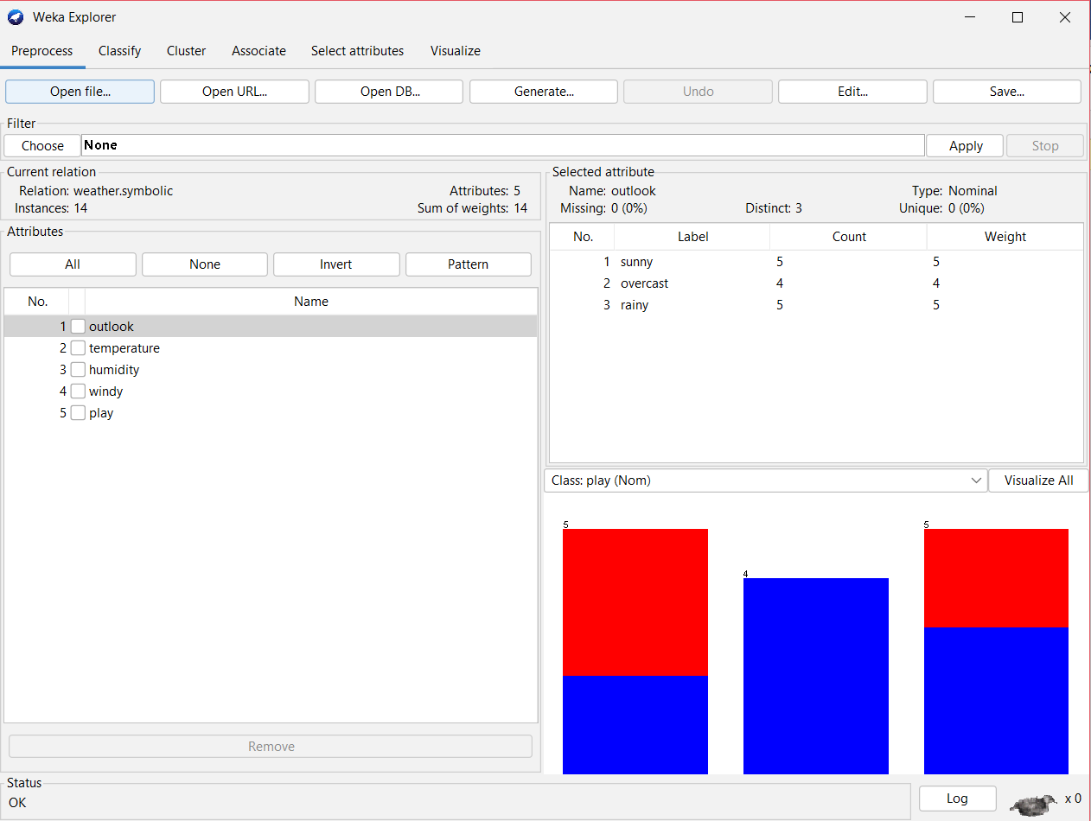

* Now, Go to classify> in classifier > choose >trees>in tress choose J48/ID3.

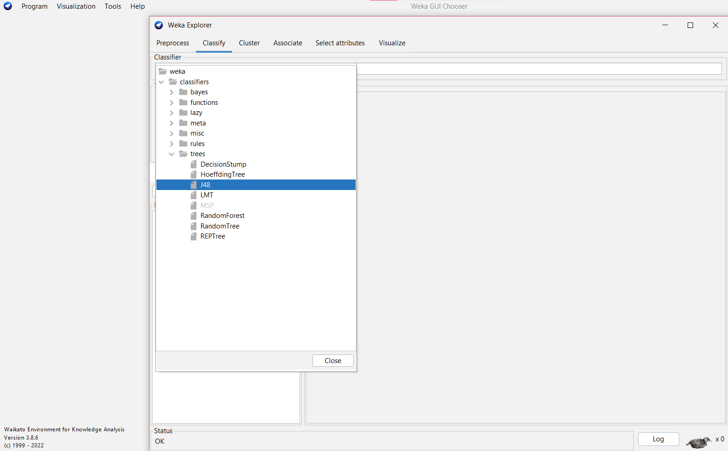

* AFTER, selecting classifier click on Start.

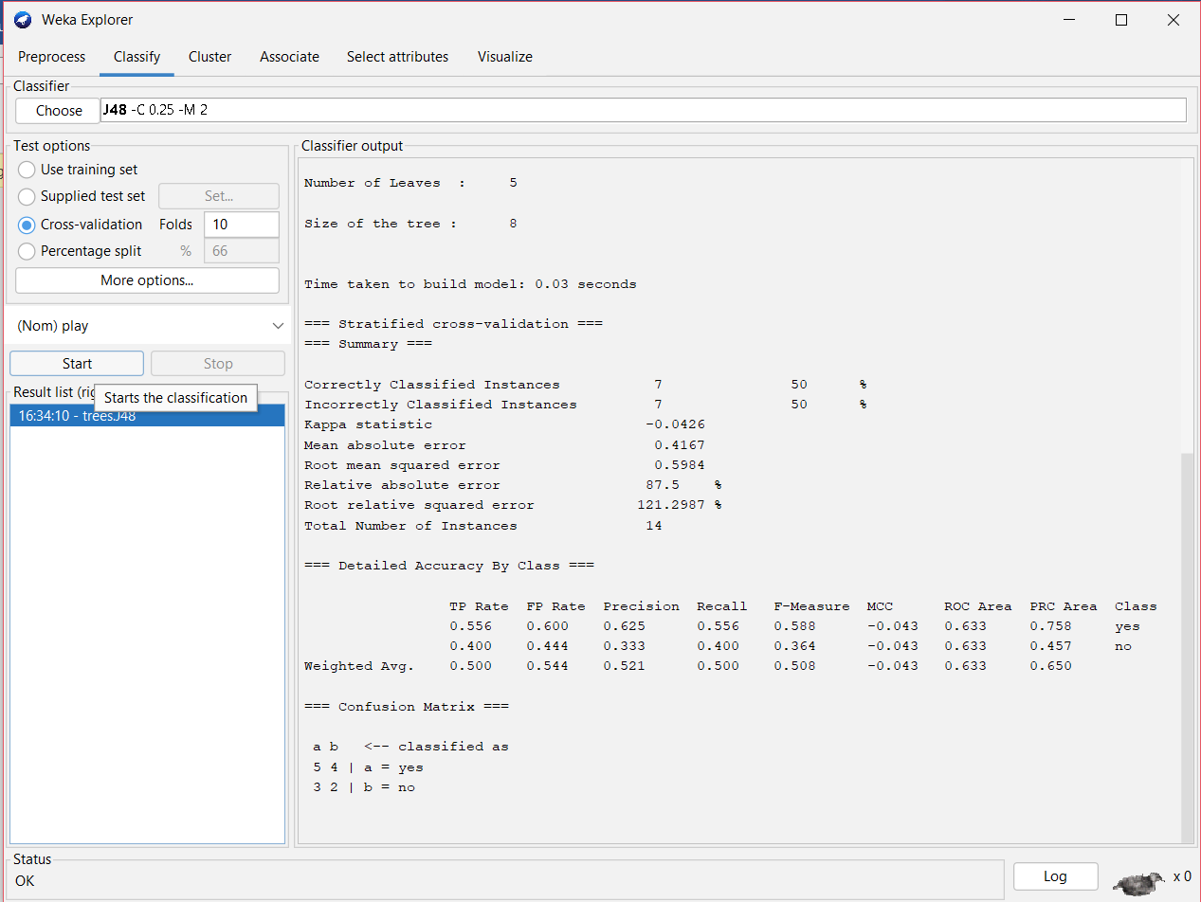

**Practical No: 8**

1. **Association problems:-**

In Preprocess > Open file> Local disk> Program files> Weka > Data>choose supermarket file> open

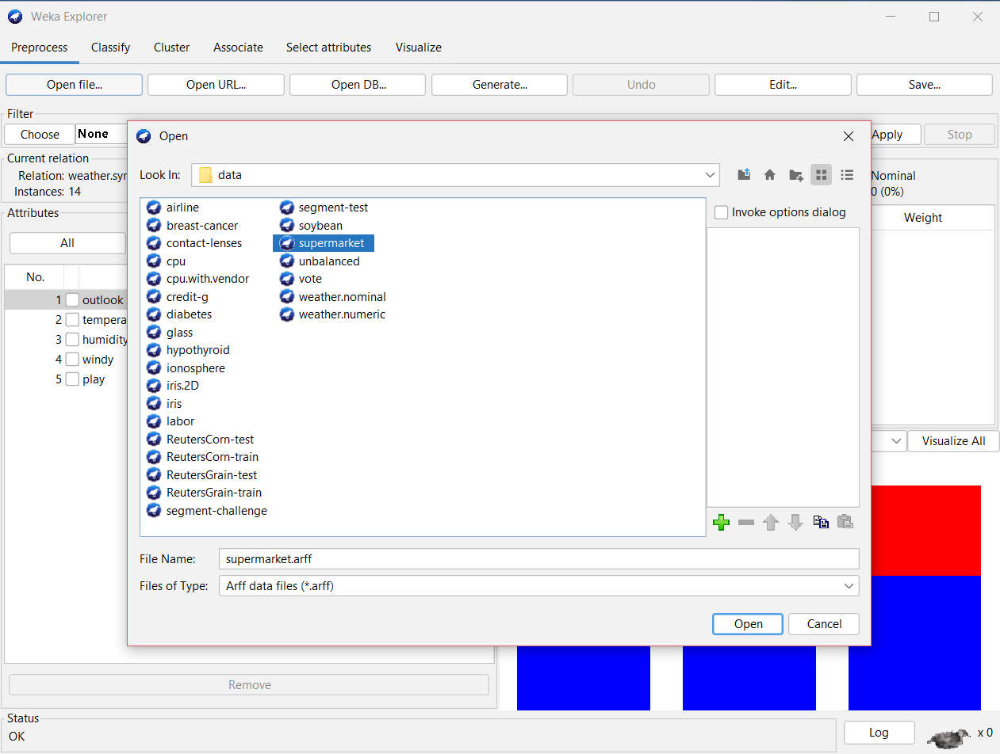

* After clicking on open u will see this window.

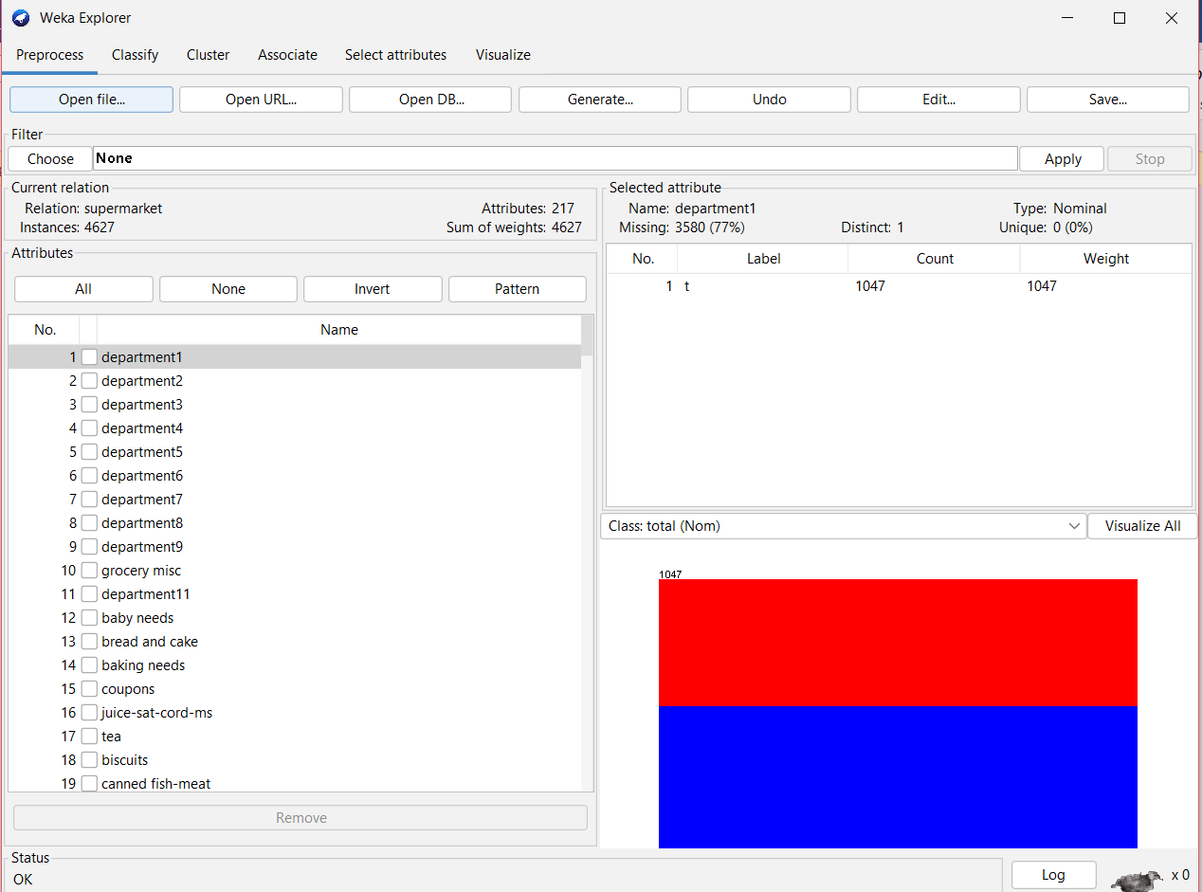

* Now, Go to associate > in associator > choose > choose Apriori.

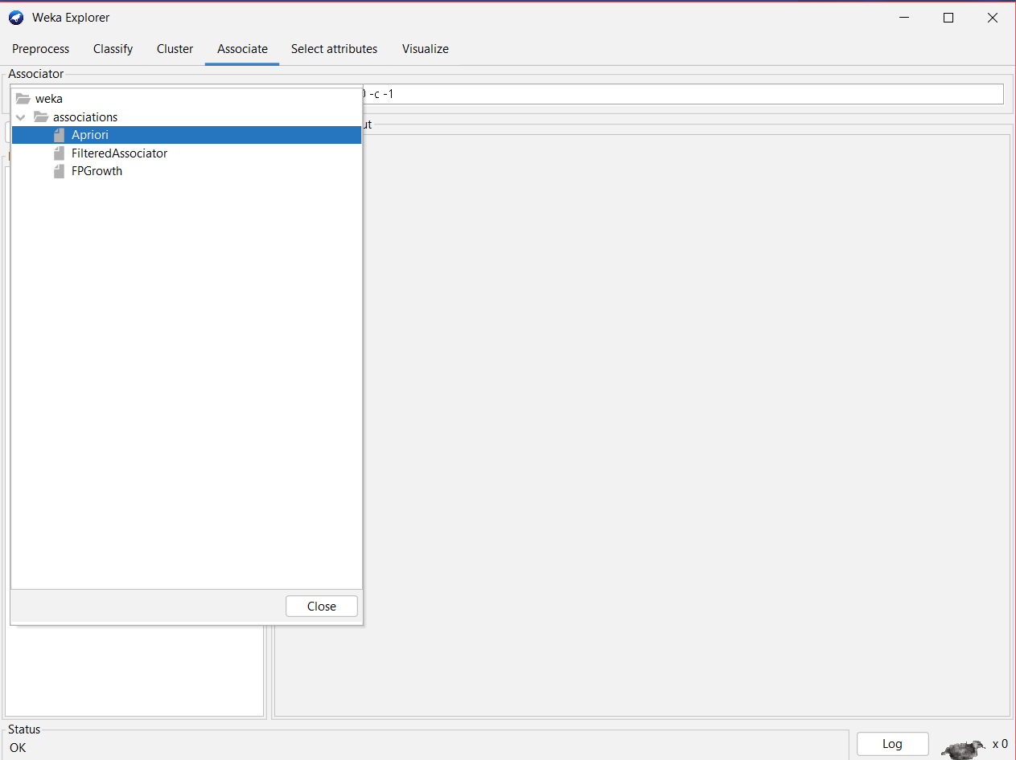

* AFTER, selecting Associator click on Start.

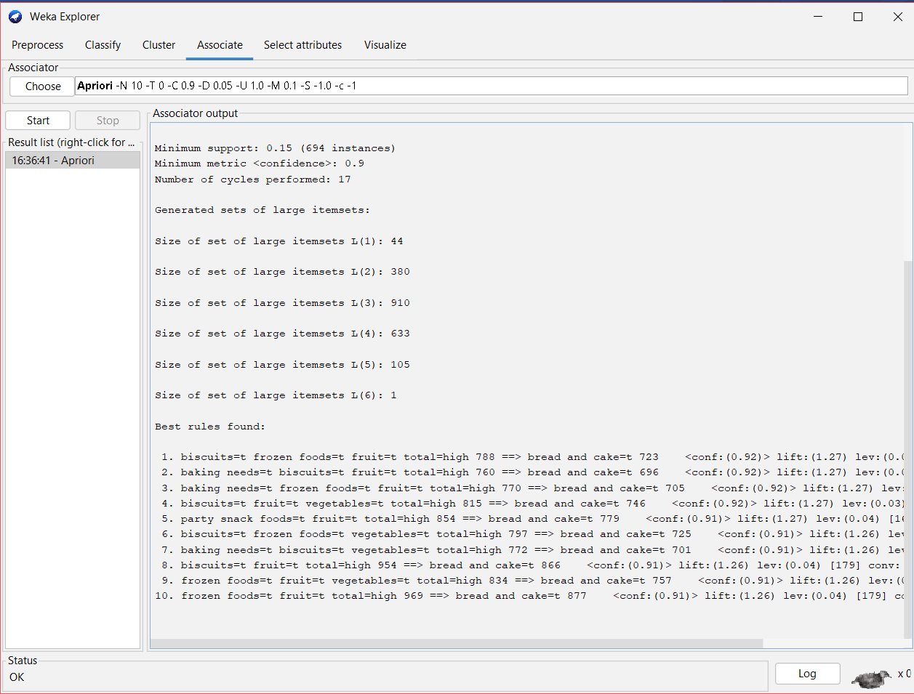

**Practical No: 9**

1. **Cluster:-** In Preprocess > Open file> Local disk> Program files> Weka > Data>choose soybean file> open

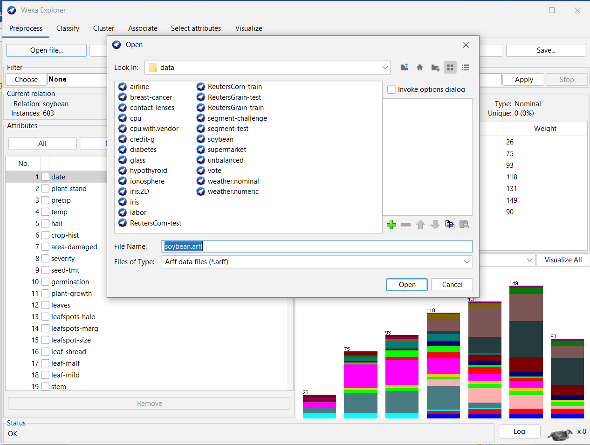

* Now, Go to cluster> in Clusterer > choose > choose SimpleKMeans

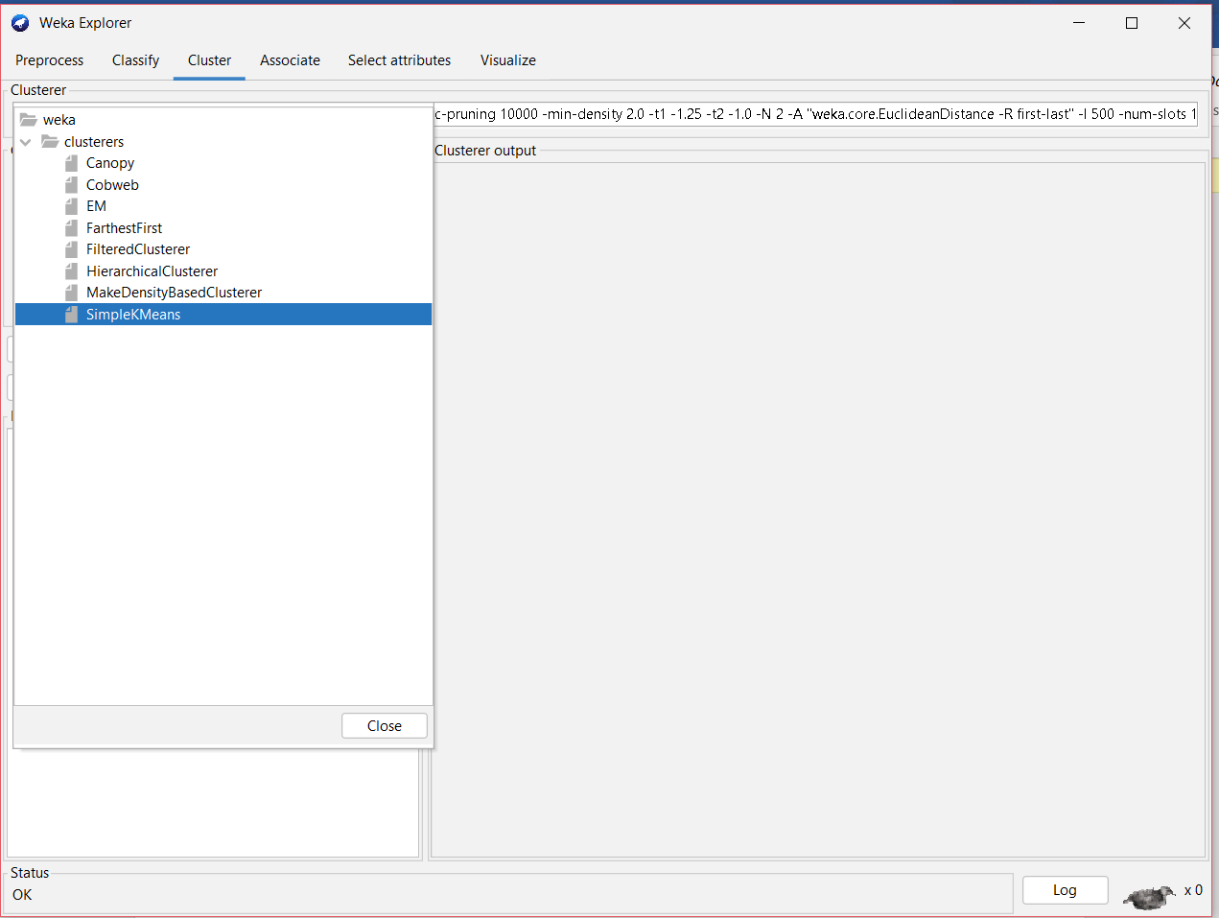

* AFTER, selecting clusterer click on Start.

